29.28: a) 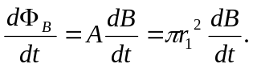
b) 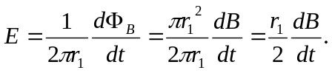
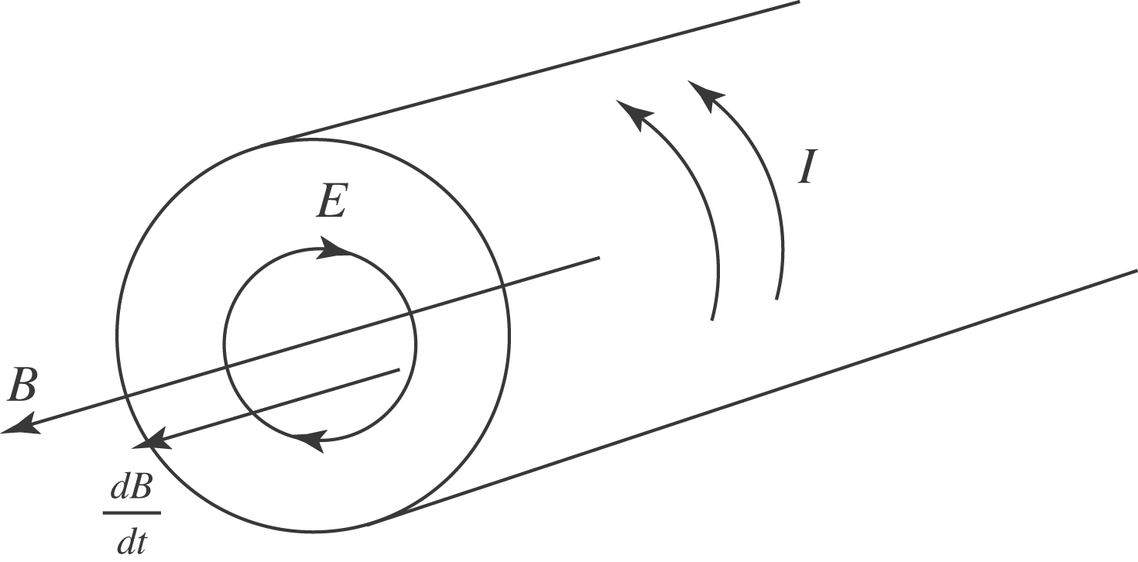

c) All the flux is within r < R, so outside the solenoid
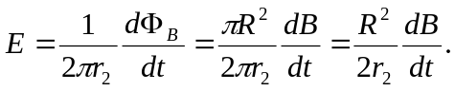

d)
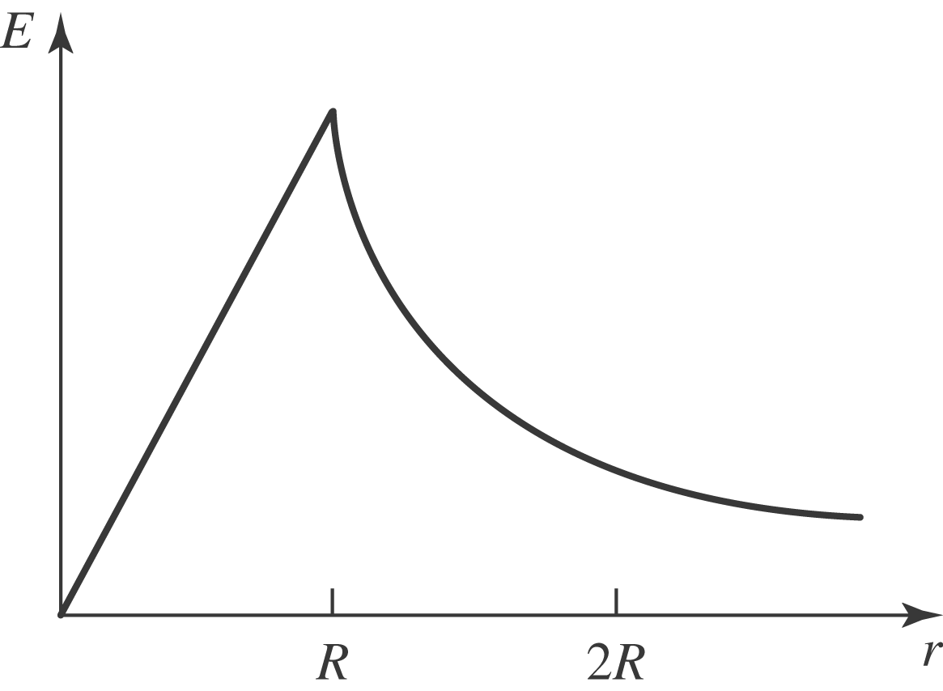
e) At 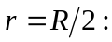
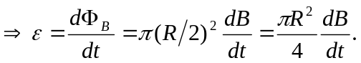
f) At 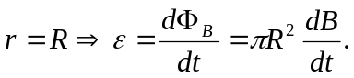
g) At 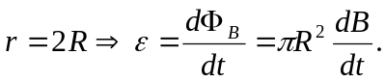 Note that the emf is independent of the distance from the center of the cylinder as long as one is outside it.

